2. GENERAL INFORMATIONS ABOUT THE EARTH

2.1. The Earth in the world space

Geology as a science that studies primarily our planet and its top stone shell does not leave without attention the surrounding material world – Universe and Solar system. This is due to the fact that there are certain similarities and differences with the other planets in the structure and evolution of the Earth, and some geolocial processes are directly related to cosmic phenomena.
Characteristics of the Universe. The whole material world around us, is called the Universe, or the cosmos (Greek cosmos – the world, the Universe). The Universe is infinite in space and time. Matter in the universe is not evenly distributed and represented by stars, planets, dust, meteorites, comets, gases. Available to study part of the Universe is called metagalaxy, consisting of more than a billion of star clusters or galaxies (from Greek galaxy – milky), among which is our Galaxy.
Even in the 20's of ХХ century it became apparent that the galaxy – is not a nebula (not clouds of gases and dust), but huge starry worlds. Our Galaxy, or the Galaxy of the Milky Way, is silver cluster, within which about 100 billion of stars are concentrated.
In the universe we know a huge number of galaxies, astrophysicists believe that there are about a billion. E. Hubble divided galaxies into several classes (fig. 2.1).

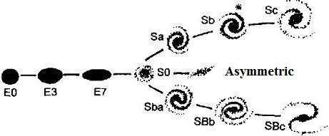

Fig. 2.1. Classification of galaxies by E. Hubble (P. Moore, 1999).
An asterisk denotes a class of galaxies to which our galaxy belongs

Spiral of Sa class is well-formed, tightly coiled hose, extending from a clear core; spiral of Sb class, to which our Galaxy is related, has more stretched sleeves, and core is less dense. Spirals of Sc class have expressed cores and sleeves widely separated from each other.
Spiral-linear galaxies have sleeves moving away from the "cross" of the cones, passing through core. They are divided into SBa, SBb, SBc.
Elliptical galaxies show no signs of spiral structure. They vary from Е7 class (strongly flattened) to Е0 (almost spherical and very similar to the globular clusters).
And, finally, there are asymmetric galaxies, which don’t have certain form. It is believed that approximately 30% of the galaxies are spiral, 60 % – elliptical and 10 % asymmetric. According to the ideas available today, the most distant systems are at a distance of 143 billion light years away and are removed at speed that is over 90% of the speed of light.
Three main types of galaxies were studied in 20-30-s of ХХ century by E. Hubble and other scientists. But galaxies of other types were known in next 70-80 years.
This primarily applies to the galaxies with active nuclei and significant radio emission. Quasars, opened in the 60s of the XXth century, stand out among them. Stellar component is not detected in them, at least it is unnoticable on the background of tremendous luminosity of dense core, reaching 10³⁰–10⁴⁰ W, that tens of thousands of times greater than the Galaxy luminosity. Interestingly, this energy comes from regions of 10³⁰-10⁴⁰ cm size, which is hundreds times smaller than the Galaxy. Radio emission of quasars is comparable in intensity to their optical emission and infrared – even more.
The most distant objects, observed using the most modern equipment,are quasars. We see quasars at large distances because they have superluminosity. With their help like the boundaries of Metagalaxy, observed region of the Universe, are outlined. And the distance to the most distant of them is thousands of thousand megaparsecs. The light from the quasars goes to us for billions of years.
Our Galaxy or Milky Way, which includes Solar system, refers to a spiral type and consists of over 150 billions of stars. Our Galaxy has discoid shape. In the plan, it is a bright star thickening – Milky Way, with с helical threads of stars in the core, there is the Sun at the periphery of one of them.
Diameter of Milky Way is about 120 thousands of light years (1 light year is 10¹³ km), and disk thickness is 1600 light years. Period of rotation of the Sun and stars around center of Milky Way is about 250 mln years.
Distance between celestial bodies in the Universe is measured in parsecs (pс). Parsec is the reciprocal of the annual parallax. 1 pс = 3,26 с.г. = 206265 а.е. = 30,857∙10¹² km.
Solar system. The structure of the solar system includes 9 planets, 42 satellites, at least 50 thousands of small asteroids (planetoids), countless meteors and hundreds of comets (fig. 2.2). Solar system is компланарна, i.е. orbits of planets are located in one plane, they coincide with the equatorial plane of the Sun and have almost round shape. Direction of planets’ rotation (except for Venus and Uranus, which have reverse rotation) around the Sun coincides with the direction of rotation of the Sun around its axis.

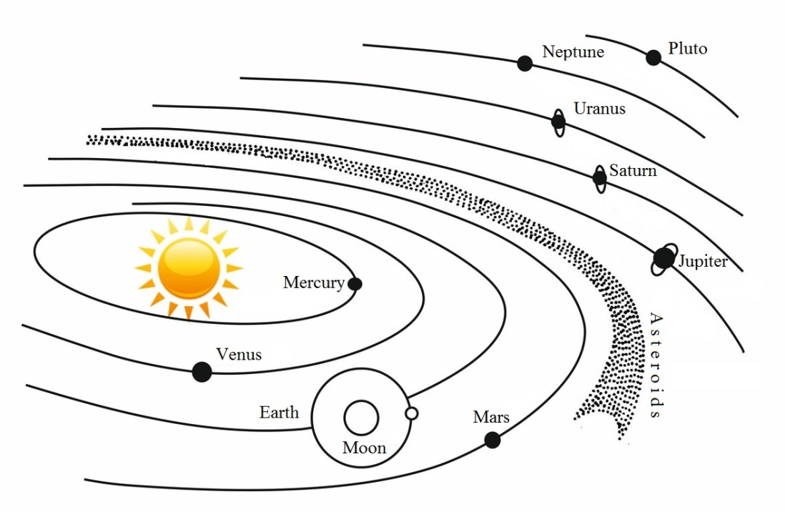
Fig. 2.2. Scheme of Solar system’s structure

Weight of the Sun is 99.87 % of whole weight of the system, and weight of the biggest of planets – Jupiter – 0.1 %. So the Sun is the center of gravity of all cosmic bodies, forming Solar system. All bodies of the system are linked by gravitational attraction and so have an impact on each other. The physical state of the Sun is a plasmatic ball. About 70 chemical elements, the main ones of which are hydrogen and helium, are set as part of the Sun. Diameter of the Sun is 109 times larger than the Earth’s, average density is 1,41 g/m³, average temperature of external layers is about 5600^{о}С. The age of the Sun is about 6–6,5 billions of years.
The thermal energy of the sun is caused by thermonuclear processes of coversion of hydrogen into helium. Per 1 s the Sun radiates 4,2×10²⁶ J. Negligibly small part (1.2 billion portion) of this amount of radiant energy falls to Earth. Heat and light emitted by the Sun, have a great impact on many geological processes.
Planets. Planets of the solar system is divided into domestic (Earth-like) and external by mutual arrangement, mass, density, and other parameters. Basic information about the planets is shown in table 2.1.
Table 2.1.

Characteristics of planets of Solar system
Planets | Radius (in relation to the earthly) | Density, g/сm³ | Mass (in relation to the mass of the Earth) | Athmosphere | Period of rotation around its axis | Period of orbital revolution | Number of satellites | Distance from the Sun, а.е.*
Mercury | 039 | 5.42 | 0.04 | He | 59 days | 88 days | - | 0.39
Venus | 0.97 | 5.11 | 0.81 | CO₂ | 243 days | 224.7 days | - | 0.72
Earth | 1 | 5.52 | 1.0 | N, O, CO₂, Ar | 23 h. 56 min. | 365.3 days | 1 | 1.00
Mars | 0.53 | 3.95 | 0.11 | CO₂, N, Ar | 24 h 37 min 29 s | 1.9 years | 2 | 1.52
Jupiter | 10.95 | 1.33 | 316.94 | NH₃, CH₄, Hе | 9 h 50 min | 11.86 years | 15 | 5.20
Saturn | 9.02 | 0.69 | 94.9 | NH₃, CH₄ | 10 h 14 min | 29.45 years | 16 | 9.54
Uranus | 4.00 | 1.56 | 14.66 | CH₄ | 10 h 49 min | 84 years | 5 | 19.19
Neptune | 3.92 | 2.27 | 17.16 | CH₄ | 15 h 40 min | 164.8 years | 2 | 30.07
Pluto | 0.16 | 1.75 | 0.0015 | Ne | 6,4 days | 248 years | 1 | 39.46
*1 а.е.= 149 598 000 km (а.е. − an astronomical unit equal to the average removal of the Earth from the Sun).

Planets of Earth group, Mercury, Venus, Earth and Mars, are relatively small in size, composed of stone and metal materials with an Earth-like type with high density, they have negligible mass of the atmosphere, characterized by a relatively low speed of rotation around the axis.
External planets, Jupiter, Saturn, Neptune, Pluto, are characterizied by huge size, low density of matter, dense atmosphere with predominance of hydrogen, helium and methane, relatively high speed of rotation around the axis. Pluto is the worst studied of all planets, the satellite of which was found only in 1978. Giant planets, Jupiter, Saturn, Uranus, are characterized by rings, composed of meteorite material.

The Earth as a planet was formed about 4,6 billions of years ago in Galaxy of Milky way, in Solar system.
The Earth differs by blue of oceans and greenish-yellow inclusions of continents when observing from the space. It has satellite – the Moon (distance from the Earth is 384 395 km, period of rotation in orbit if 27 days). The strength of the influence of the moon on the Earth in the form of tidal water and stone shell of our planet due to the small distance between them and commensurability of size (the Moon is 4 times less than the Earth, the weight is 81 times less than the Earth’s weight). Density of the Moon is 3,3 g/cm³, force of gravity on the Moon is 6 times less than on the Earth, it is explained by its lack of atmosphere. Processes of rocks’ destruction under the influence of solar radiation (daily differential of temperatures 300^{о}), meteoritic bombardment and also magmatic (predominantly volcanic) activity are characteristic to the Moon. Thickness of moon crust is between 30 and 65 km. Its upper part composed of regolith – products of root basalts’ destruction. Below, it is supposed to be the mantle (to depth 2900 km) and core.
It is considered, that the Earth has shape of geoid. Polar radius is 6356 km, equatorial radius is 6378 km, and average radius is 6371 km.
Hypsographic curve represents common structural regularities of earth surface. Average height of continents is 875 m, and average depth of the World Ocean is about 3800 m. There is marked out shelf, continental slope, World Ocean lodge, which is complicated by deep-sea depressions (troughs) and mid-ocean ridges in structure of ocean floor.
Asteroids. There is a belt of asteroids or small planets between orbits of Mars and Jupiter, separating internal planets from external. About 2000 asteroids are opened, it is believed, that their total number is over 100 thousand with a total weight about 0,001 of the Earth’s weight. The biggest of them are: Ceres (diameter is 767 km), Pallas (489 km), Vesta (386 km), and Juno (190 km). Asteroids have iron-stone composition and shape of angular boulder.
Comets – space bodies of elongated shape and which have composition, close to the composition of atmospheres of planets-giantes. They move on highly elliptical orbits, passing close to the Sun and going away from it beyond the orbit of Pluto. Comets are not hot bodies; their light is caused by solar radiation. It was found about 1000 comets. Comets can collide with planets forming sinkholes – craters in case of deviation from the orbit. It is believed that the Tunguska meteorite, which fell in June 1908 in Siberia, was a small comet (with weight about 5 mln t), collided with the Earth. Comet of Halley is related to so-called periodic comets. Period of its rotation is about 76 years. It appeared in the sky 30 times between 446 y. BC and 1986 y.
Meteorites are mineral aggregates of space origin, flying from outer space into the Earth’s atmosphere. Small meteors burn up in the atmosphere, the largest reach the surface, forming explosive funnels in the form of a crater when hitting. The largest crater is Meteor (Arizona, USA) with diameter of 1.6 km and depth of 150 m. total number of observed meteors falling, according to F. Stacey, is over 700. In two cases (Prishbram in the Czech Republic and the Lost City in the USA) meteors have been photographed, which allowed reliably calculate their orbits.
On the composition of meteorites are divided into iron (siderite), stone (eucrites) and iron-stone (chondrites). Siderites by 95% consist of iron and contain impurities of nickel and cobalt; on the composition, apparently, they correspond to core of the Earth. Eucrites consist of silicates with impurity of nickeliferous iron and close on composition to some rocks of earth crust. Chondrites, the most widespread (93% of all finding), approach to the composition of the Earth as a whole.
The Earth gets about 16 thousands tons of meteoritic matter per year. The weight of meteorites varies between few grams and hundreds of tons. The largest of found meteorites are Goba (Africa) with the weight of 59 t, Cape York (Greenland) – 33 t. Large meteorites in Russia are Boguslavka (1916) with the weight of 257 kg and Sikhote-Alin (1947) with the weight of 130 kg.
A lot of meteorites were found in territory of Kazakhstan too. Thus, there is information about 5 meteorites, found in territory of Kazakhstan in an article «Meteorites» in 3rd volume of «Siberian Soviet Encyclopedia», published in 1932 in Novosibirsk. They have these characteristics: 1) Karakol – fell in midday on 9 May 1840 in area of former Ayagoz county, white chondrite, initial weight is 3 kg, cone-shaped; 2) Yamysheva – palassite, was found in 1885 near village of Yamysheva former Pavlodar county, initial weight is 4,5 kg, its small pieces were transferred in various museums of the world; 3) Bestobe was found in Bestobe terrain near village of Nikolayev of Torgay region, octahedrite of larger structure, content of nickel in it is 6,48 %, initial weight of three specimens is 48.25 kg, rhe main specimen is kept in Mining museum; 4) Mayskiy - chondrite, was found in terrain of forty wells of Mamyr on the border of former Shymbay and Kyzylorda counties, locals dismantled piece by piece, piece with weight of 58.8 g is in museum of Academy of Sciences; 5) Tarbagatay – the time of fall is unknown, fragment with weight of 101 g was transferred into a museum of Academy of Sciences.

2.2. Structure, properties and composition of the Earth

The Earth as the most developed planet of Solar system, is characterized by shell structure with a central symmetry. Shells of the Earth (geospheres) differ by composition, physical properties, state of matter and are divided into external and internal. External geospheres are available for direct study. Internal geospheres are explored mainly by indirect methods (geological, geophysical, geochemical). External and internal geospheres of the Earth are closely connected between each other and outer space.
External geospheres. The Earth is surrounded by atmosphere. Its lower shell (troposphere) extends to an average height of 14km; occuring processes play a decisive role role for formation of weather on the planet. Temperature in troposphere decreases by increasing of height. Shell between 14 and 50–55 km is called stratosphere; temperature increases by increasing height here. Even higher (about 80–85 km) there is a mesosphere, over which there are (usually at the height about 85 km) silver clouds.
Ozonosphere – layer of ozon, which is at the height between 12 and 50 km – has great importance for biological processes on the Earth. Area above 50-80 km is called ionosphere. There are first and second radiation belts at height about 1.6 and 3.7 radiuses of the Earth.
Hydrosphere – water shell of the Earth, which contains all surface and underground water, glaciers.
Biosphere – sphere of organic life. Upper border is bounded by ozone acreen, а lower border according to V.I. Vernadskiy must lie above areas, where hot steams of water dominate and temperature doesn’t go down lower 100⁰С, the average level at 3–4 km from the level of the geoid. I.е. the position of this border is the limit (quiet high) temperature, in which the simple organisms can exist.
Internal geospheres. Seismical metods, based on study the spread of elastic waves in its thicker, which arise during seismic events – during natural earthquakes and as a result of explosions have the main role in researching internal structure of the Earth. Internal geospheres: lithosphere, mantle, core, which are limited to sections of the I and II order (fig. 2.3).

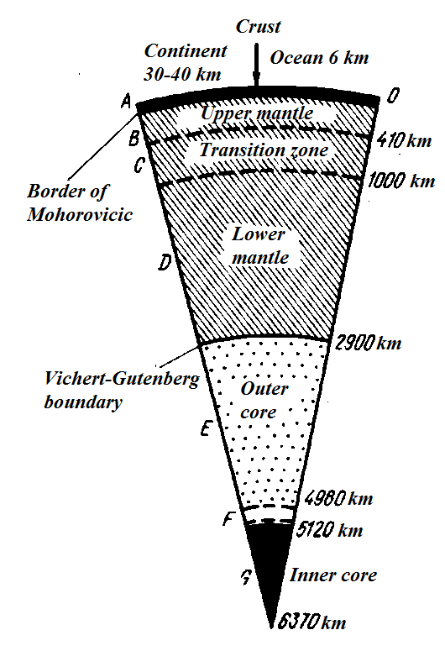
Fig. 2.3. Internal structure of the Earth
(model of Gutenberg-Bullen)

Lithospere – stone shell of the Earth. Upper part of lithosphere is earth crust; it has heterogeneous structure horizontally and vertically. Lithospere is divided into plates that move along the asthenosphere with various speeds.
Asthenosphere, or seismic waveguide - a layer of low hardness, strength and toughness in the upper part of the Earth's mantle at a depth of 100 km under the oceans and about 200 km under the continents, with the lower boundary at a depth of about 200-400 km, within which the centers of volcanoes lie and subcrustal mass movement is carried, which causes tectonic processes.
Mantle – shell of the Earth, located between the crust and the core. It consists of two layers: upper mantle (to a depth of 900 km) – it takes a part in orogenic processes; and lower mantle (to a depth of 2900 m).
Core – area in the Earth, starting from a depth of 2900 km. There are outer core (up to a depth of about 5100 km), and the inner core of the Earth, which is located, starting from a deoth of 5000 km till the center of the Earth.
There are borders (sections) between earth speres, charactered by difference in passing of seismic waves. These sections were determined by seimic devices. Sections of the first order are determined by a sharp jump in the speed of seismic waves and fix borders between main shales of the Earth – crust and mantle (section of Mohorovicic discontinuity), mantle and ore (section of Wiechert-Gutenberg). Sections of the second order register internal heterogeneity within Earth crust, mantle and core. Slew rate of seismic velocities changes to the depth here.
Geophysical fields of the Earth
The gravitational field of the Earth is described with high accuracy by the law of universal gravitation of Newton. It shows the nature of the mass distribution within the planet, and is closely linked to the figure of the Earth. The gravitational field can be represented as the sum of the normal (planetary) field due to weight, shape and speed of rotation of the Earth and anomalous field. Gravity anomalies are the result of differences in the structure of the real and ideal Earth. Various force of gravity is characteristic for each point of earth surface, in the center of the Earth force of gravity is equal to zero. The peculiarity of the gravitational field of the Earth is its comparative constancy at certain time intervals. There is a change in the gravitational field at various tectonic processes that lead to mass displacement and a partial restructuring of the structure of the Earth.
Density of the Earth’s matter determines speed of distribution of seismic waves in its interior. Seismometric method (or seismic exploration) is based on the study of seismic waves in the Earth's crust; it now occupies a leading position among the other geophysical methods. Artificial source of excitation of elastic waves, usually an explosion in a shallow well is used in seismic exploration (fig. 2.4). Seismic waves, reaching borders of speeds’ change, reflect and come to system of registrations, consiting of devices series – seismographs. Time of wave motion from the shot to each seismograph is plotted in the form of curves called hodographs.
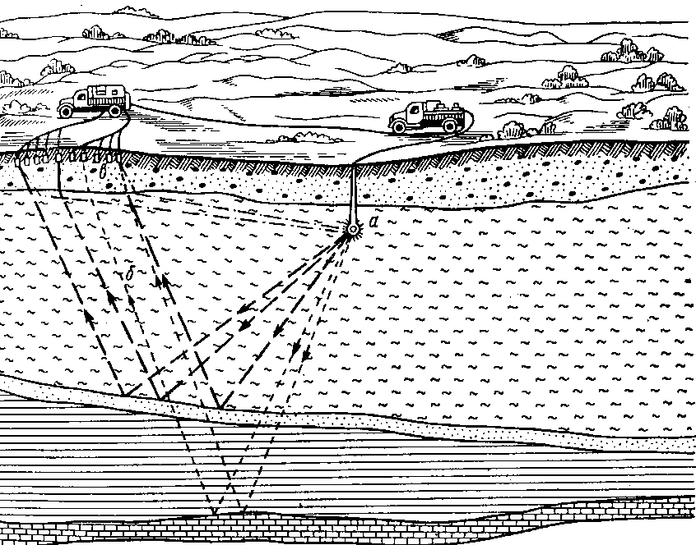
Fig. 2.4. Scheme of seismic survey by method of reflected waves: а – artificial explosion; б – reflected; в – geophones

Radioactive field. The distribution and concentration of atoms of radioactive elements in the earth's crust and in the whole of our planet have particular importance. The decay of these elements generates heat, largely determining the thermal regime of the Earth. Radioactivity of rocks and minerals that form the earth's crust, are studied with the device - radiometer. The method of studying the radioactivity of rocks called radiometry. Radioactivity of rocks in boreholes is studied by gamma logging. The intensity of radioactivity of rocks is measured in mcR/h.
Thermal field. The thermal field of the Earth is formed by external and internal sources. The source of external energy is the solar radiation. The sources of internal heat are the radioactive decay of elements, the energy of the gravitational differentiation of matter; the residual heat that has survived since the formation of the planet. The earth's crust is divided into the upper– solar thermal zone and lower – geothermal zone by temperature conditions. Thermal field is characterized by the geothermal gradient and the geothermal step. Geothermal gradients of various regions of the earth differ greatly from each other and vary in the range from 0,1 to 0,01^{о}С/м. The average value of geothermal gradient is 3^{о}С на 100 m. The inverse value - geothermal stage shows the distance that you need to go deep, in order to temperature be increased by 1^{о}С.
Magnetic field. The Earth also has magnetic field. Earth acts as a permanent magnet. The geomagnetic field is dipole. It exists around the globe and within it, extends beyond the planet at a distance of 10 times greater than the radius of the Earth. The magnetic field is asymmetrical. Currently, the magnetic poles are slightly displaced in relation to the geographical. The angle between the magnetic axis and the rotation axis is approximately 11,5⁰. North Magnetic Pole is among Canada's Islands and the south is in Antarctica. Their position is gradually changing over time. Magnetic inversion, ie reversing the polarity is detected over geological time intervals, according to paleomagnetic data.
Declination– due to the fact that the magnetic and geographic poles do not coincide, the compass arrow doesn’t point to true north or south anywhere except on one line across the eastern part of the United States in the direction NW - a line of zero declination. To the east and west from it compass needle makes an angle with the geographical meridian, called magnetic declination.
Inclination – another feature of the geomagnetic field measured by the magnetic inclinometer - arrows, oscillating about a vertical graduated scale. It shows the inclination angle defined as the angle between the magnetic field lines and the horizontal plane.
Origin of Earth's magnetic field. The constant magnetic field is caused by the complex system of electrical currents, accompanying the turbulent convection in the liquid outer core, ie, Earth acts as a dynamo, in which mechanical energy of convection system generates electric currents and associated magnetics.
Magnetic anomaly is a local deviation from the regional average value of the magnetic field. In the oceans, the anomalies are caused by polarity inversion. Bands of intensive positive and negative anomalies extend along the mid-ocean ridges. They were formed as a result of the rise of a new lava and its cooling in a magnetic field – normal or inverted (that which prevailed at the time), and as a result of subsequent moving apart the sea floor from the side of the ridge, where the lava were born. Anomalies are the story of reversals of the magnetic field and the sea-floor spreading. On land anomalies are related to the type and structure of the rocks. These anomalies help to find iron ore.
Electrical field is closely linked to the Earth's magnetism. It is shown, particularly, in the form of telluric currents; local electric fields occur at the boundaries of sulphide ore bodies, during the circulation of saline water, etc. Distribution of electric current in the Earth's crust is largely due to the peculiarities of its geological structure, causing the distribution of electrical properties of rocks. Its main feature is their electrical resistivity, measured in Ohms ∙ m. Geophysical methods for studying the internal structure of the Earth's crust and exploration of mineral deposits were developed on the basis of the use of natural electric field of the Earth. Electrical prospecting (electrical exploration) methods are used with this purpose, which are based on the use of natural or artificial (induced) electric fields of direct or alternating current in the field or in boreholes (electric logging).
Chemical composition of the Earth
According to the latest data, there are 285 chemical elements and their isotopes on the Earth. Academician A.E. Fersman described state of our knowledge about the chemical components of the Earth: well-known – 1,1 %, partially known – 3,6%; unknown at all – 95,3%. First numerals (1,1 and 3,6 %) are related to upper horizons of the earth crust. The study of the chemical composition to a depth of 16 km was engaged by American geochemist Clarke Uiglsuort Frank (1847-1931), who dedicated this issue 40 years of his life and published the first results of the count in 1889. In honor of his A. E. Fersman in 1923 proposed naming clarkes average content of chemical elements in the earth's crust, calculated for the whole of its volume and expressed in weight or volume percentages.
Comparison of composition of the Earth as a whole with the composition of the upper shell of the crust reveals a sharp increase in the first fraction of heavy elements - iron and nickel (respectively, in the Earth - 35-40%, and in the earth's crust - 2.4-3.5%), due to the influence of core. According to modern views the Earth's core has, in all probability, an iron-nickel composition close to the composition of siderolites (iron-stony meteorites). The transition layer in the depth range of 4980-5120 km (F zone), according to researchers, consists of iron sulfide - troilite FeS, representative compound of siderolites (fig. 2.5).

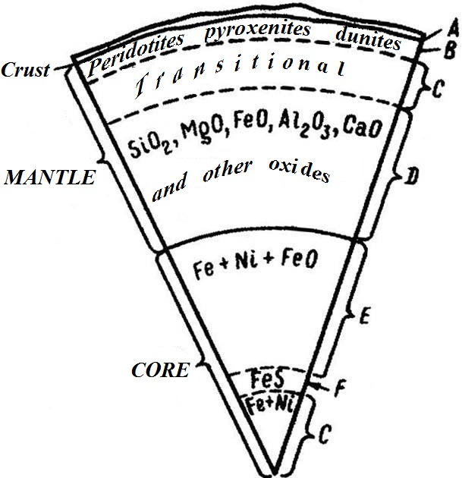
Fig. 2.5. Section of the Earth with allocation of areas of different chemical composition

Mantle of the Earth is the largest geosphere by volume and weight and has a rather complicated structure, which can be judged on the basis of modern ideas about formation of geospheres. According to these ideas geospheres are the result of the differentiation (stratification) of the primary material of the Earth as a result of heating its bowels. In the first stage of differentiation heavy metals - iron and nickel, which fell down and formed the modern Earth's core, melted of the primary substance. Remained after the melting of heavy metals substance - Pirolite (by names of the main constituent minerals - pyroxene and olivine) is a modern mantle. The process of differentiation of the mantle material continues at the present time.
Earth crust, according to modern concepts, is a result of differentiation of matter. It is composed of elements compound formed in thermodynamic conditions characteristic crust horizons. These compounds are called minerals and are included in the rocks.

Control questions
- Characteristics of external geospheres.
- Characteristics of internal geospheres.
- What are known boundaries of shells and layers of the Earth?
- What is the scientific value of the gravitational field of the Earth?
- What is the scientific value of the radioactive field of the Earth?
- What is the scientific value of the thermal field (geothermal) Earth?
- What is the scientific value of the magnetic field Earth?
- What is the scientific value of the electric field Earth?
- Characteristics of the material composition of the Earth.

